County Population 2014
 | Population 2014
JEFFERSON COUNTY | 30,228
MASON COUNTY | 60,711
KITSAP COUNTY | 254,183

County Land Statistics (acres)
 | TOTAL LAND AREA | FEDERAL LANDS | STATE LANDS | TRIBAL LANDS | CITY/COUNTY | PRIVATE
JEFFERSON COUNTY | 1,162,056 | 707,766 | 205,901 | 7,161 | 1,214 | 240,013
MASON COUNTY | 621,088 | 164,538 | 81,859 | 6,107 | 0 | 368,586
KITSAP COUNTY | 254.380 | 9,852 | 22,612 | 8,328 | 11,469 | 202,120

Land Cover - Measured by Moderate Resolution Imaging Spectroradiometer (acres)
 | FOREST | GRASS/SHRUB LAND | WATER
JEFFERSON COUNTY | 1,010,989 | 93,144 | 23,241
MASON COUNTY | 571,401 | 9,893 | 24,844
KITSAP COUNTY | 234,030 | 1,228 | 10,175

Residential Development – trends in residential land-use conversion between 2000 and 2010.
 | RESIDENTAIL  ACRES 2000 | RESIDENTIAL  ACRES 2010 | %  CHANGE | LAND CLASS ↑ Δ
JEFFERSON COUNTY | 49,860 | 69,201 | +38.8 | Exurban – 1.7-40 acres/unit
MASON COUNTY | 104,582 | 125,171 | +19.7 | Exurban – 1.7-40 acres/unit
KITSAP COUNTY | 175,555 | 174,058 | -0.9* | Urban <1.7 acres/unit – convert exurban to urban
*Small percentage of change can occur in counties that are already highly urbanized in 2000.
Residential Development – per capita residential area (acres) 2000 and 2010.
 | PER CAPITA  ACRES 2000 | PER CAPITA  ACRES 2010 | CHANGE
JEFFERSON COUNTY | 1.89 | 2.31 | ↑
MASON COUNTY | 2.11 | 2.06 | ↓
KITSAP COUNTY | 0.75 | 0.69 | ↓

Population growth is often a key metric used to describe human effects on natural resources. However, in most geographies land consumption is outpacing population growth. In these areas, land consumption (the area of land used for residential development) is strongly related to wildlife habitat loss and the degree to which public lands are bordered by residential development. The impact of residential development on ecological processes and biodiversity on surrounding lands is widely recognized. They include changes in ecosystem size, with implications for minimum dynamic area, species–area effect, and trophic structure; altered flows of materials and disturbances into and out of surrounding areas; effects on crucial habitats for seasonal and migration movements and population source/sink dynamics; and exposure to humans through hunting, exotics species, and disease.

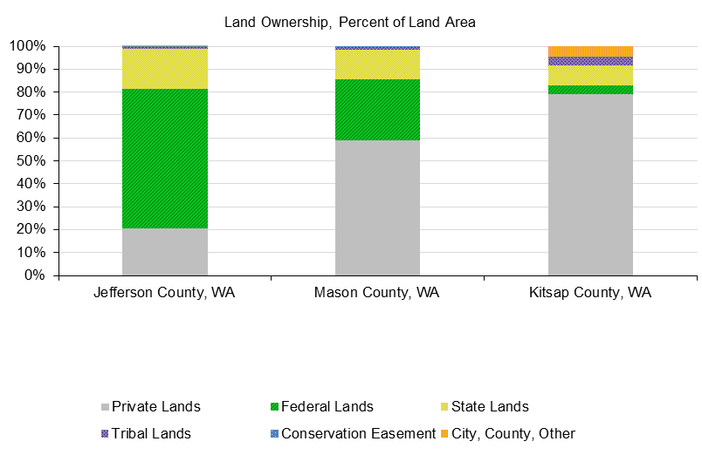
- Jefferson County has the largest share of federal public lands (60.9%; ~708,000 acres) and Kitsap County has the smallest (8.9%; ~9,800 acres)
- Jefferson County has the largest share of state public lands (17.7%; ~206,000 acres) and Kitsap County has the smallest (8.9%; ~23,000 acres).
- Kitsap County has the largest share of private lands (79.5%; 202,120).

Economic Profile System (EPS) May 17, 2016. A Profile of Land Use. headwaterseconomics.org Data Sources: US Geological Survey, Gap Analysis Program 2012. Protected Areas Database of the United States (PADUS) version 1.3.
NASA MODIS Land Cover Type Yearly L3 Global 1km MOD12Q1, 2006.
Theobald, DM. 2013. Land use classes for ICLUS/SERGoM v2013. Unpublished report, Colorado State University
Theobald, DM. 2013. Land use classes for ICLUS/SERGoM v2013. Unpublished report, Colorado State University

