Hood Canal Coordinating Council
Jefferson, Kitsap & Mason Counties;
Port Gamble S'Klallam & Skokomish Tribes

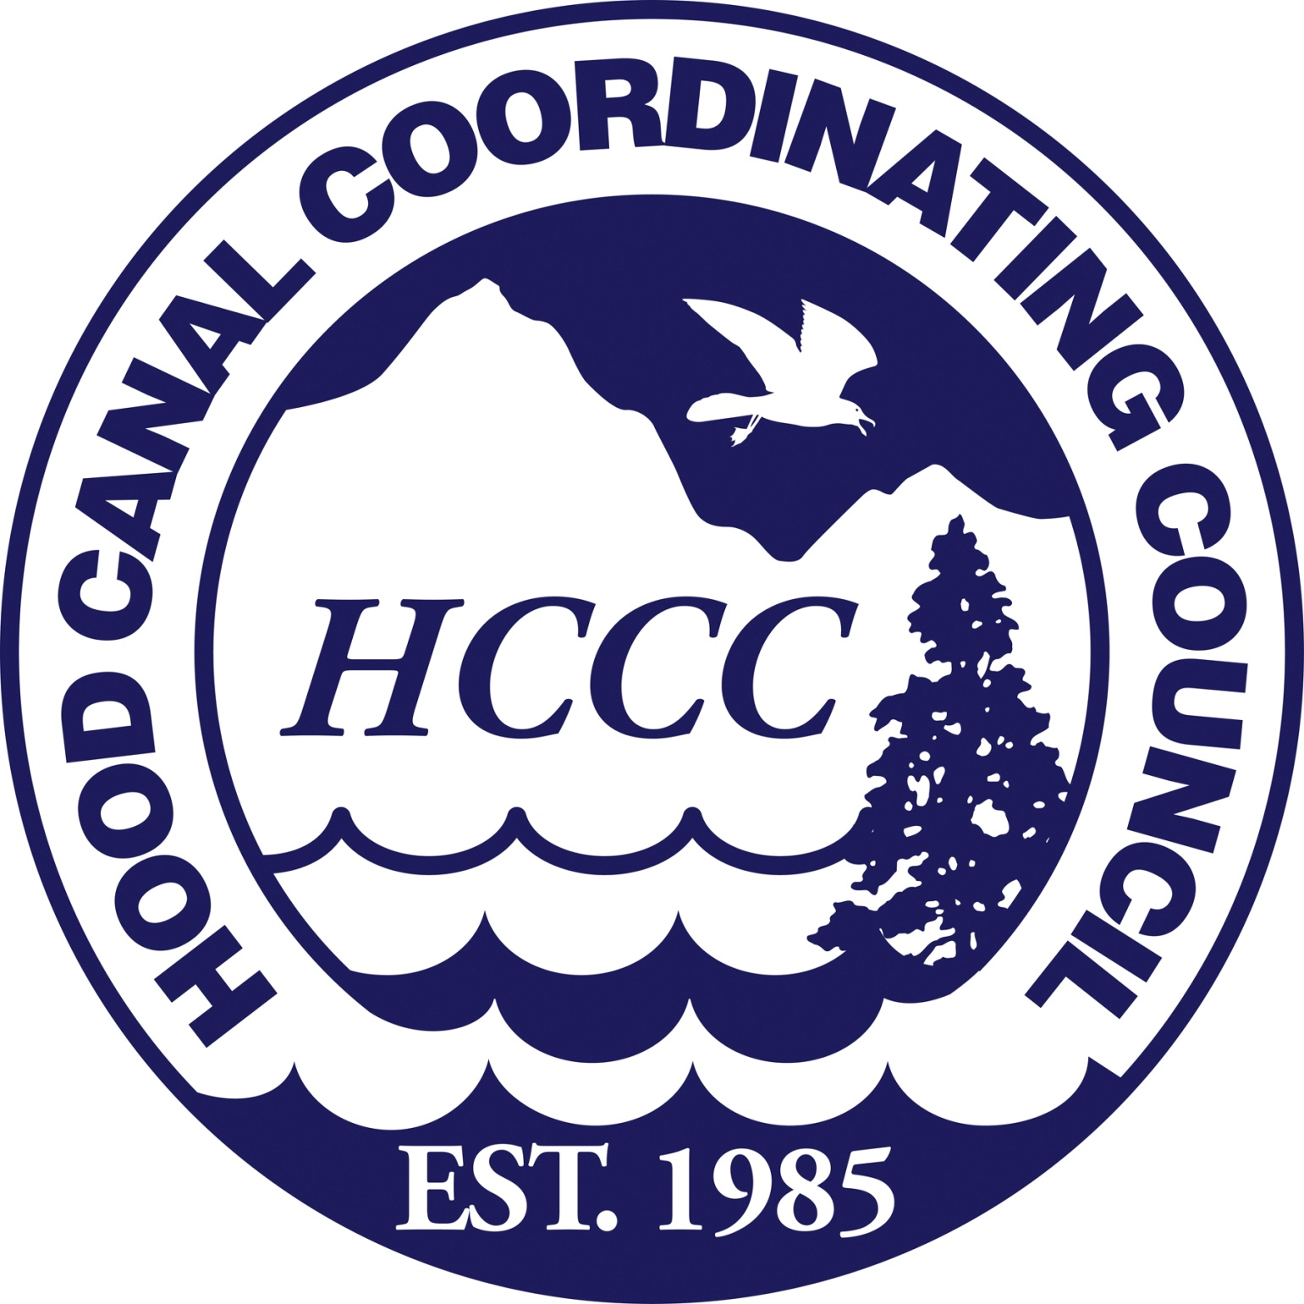

Special Meeting of the Board of Directors – Draft Agenda
March 24, 2017; 11:00 to 11:30 AM
Location: HCCC office at Liberty Bay Marina, 17791 Fjord Drive NE, Suite 124, Poulsbo, WA
and via Webex.com teleconference

11:00 a.m. Call to Order, Introductions and Approval of Meeting Agenda
David Herrera, HCCC Chair

11:05 Public Comment
David Herrera, HCCC Chair

11:10 Purpose of the Special Meeting
The purpose of the meeting is to continue discussions from the March 8, 2017 Board meeting and determine whether the HCCC Board of Directors will approve a letter of support for Richard Corff, The Trust for Public Land, and its grant application to the Sentinel Landscapes Federal Coordinating Committee regarding a Sentinel Landscape Designation for a portion of the Hood Canal watershed.

11:30 a.m. Adjournment
David Herrera, HCCC Chair

For more information about this meeting contact Robin Lawlis, 360-394-0046 or rlawlis@hccc.wa.gov.

HCCC Board of Directors

Charlotte Garrido, Kitsap County
David Herrera, Skokomish Tribe
David Sullivan, Jefferson County
Edward Wolfe, Kitsap County
Jeromy Sullivan, Port Gamble S’Klallam Tribe
Kate Dean, Jefferson County
Kathleen Kler, Jefferson County
Kevin Shutty, Mason County
Paul McCollum, Port Gamble S’Klallam Tribe
Randy Neatherlin, Mason County
Rob Gelder, Kitsap County
Terri Jeffreys, Mason County

Exofficio Members

Puget Sound Partnership
US Navy Region Northwest
Washington State Dept. of Ecology

HCCC Staff

Alicia Olivas, Lead Entity Program Coordinator
Haley Harguth, Watershed Planning and Policy Coordinator
Heidi Huber, Programs Development Coordinator
Patty Michak, Mitigation Program Manager
Robin Lawlis, Administrative Program Manager
Scott Brewer, Executive Director
Tom Goishi, Accountant

The Hood Canal Coordinating Council is a Watershed-Based Council of Governments consisting of Jefferson, Kitsap and Mason Counties and the Port Gamble S’Klallam and Skokomish Tribes. It was established in 1985 in response to community concerns about water quality problems and related natural resource issues in the watershed.

Mission: The Hood Canal Coordinating Council works in partnership with its member counties and tribes, state and federal governments, organizations, and citizens to advance a shared regional vision to recover and protect Hood Canal’s environmental and economic health and wellbeing.

Vision: HCCC envisions that humans benefit from and coexist sustainably with a healthy Hood Canal.

Visit www.ourhoodcanal.org for more information on the Integrated Watershed Plan.

Board meetings schedule, agendas and documents can be found on the website at www.hccc.wa.gov.

