Hood Canal Coordinating Council
Jefferson, Kitsap & Mason Counties;
Port Gamble S'Klallam & Skokomish Tribes

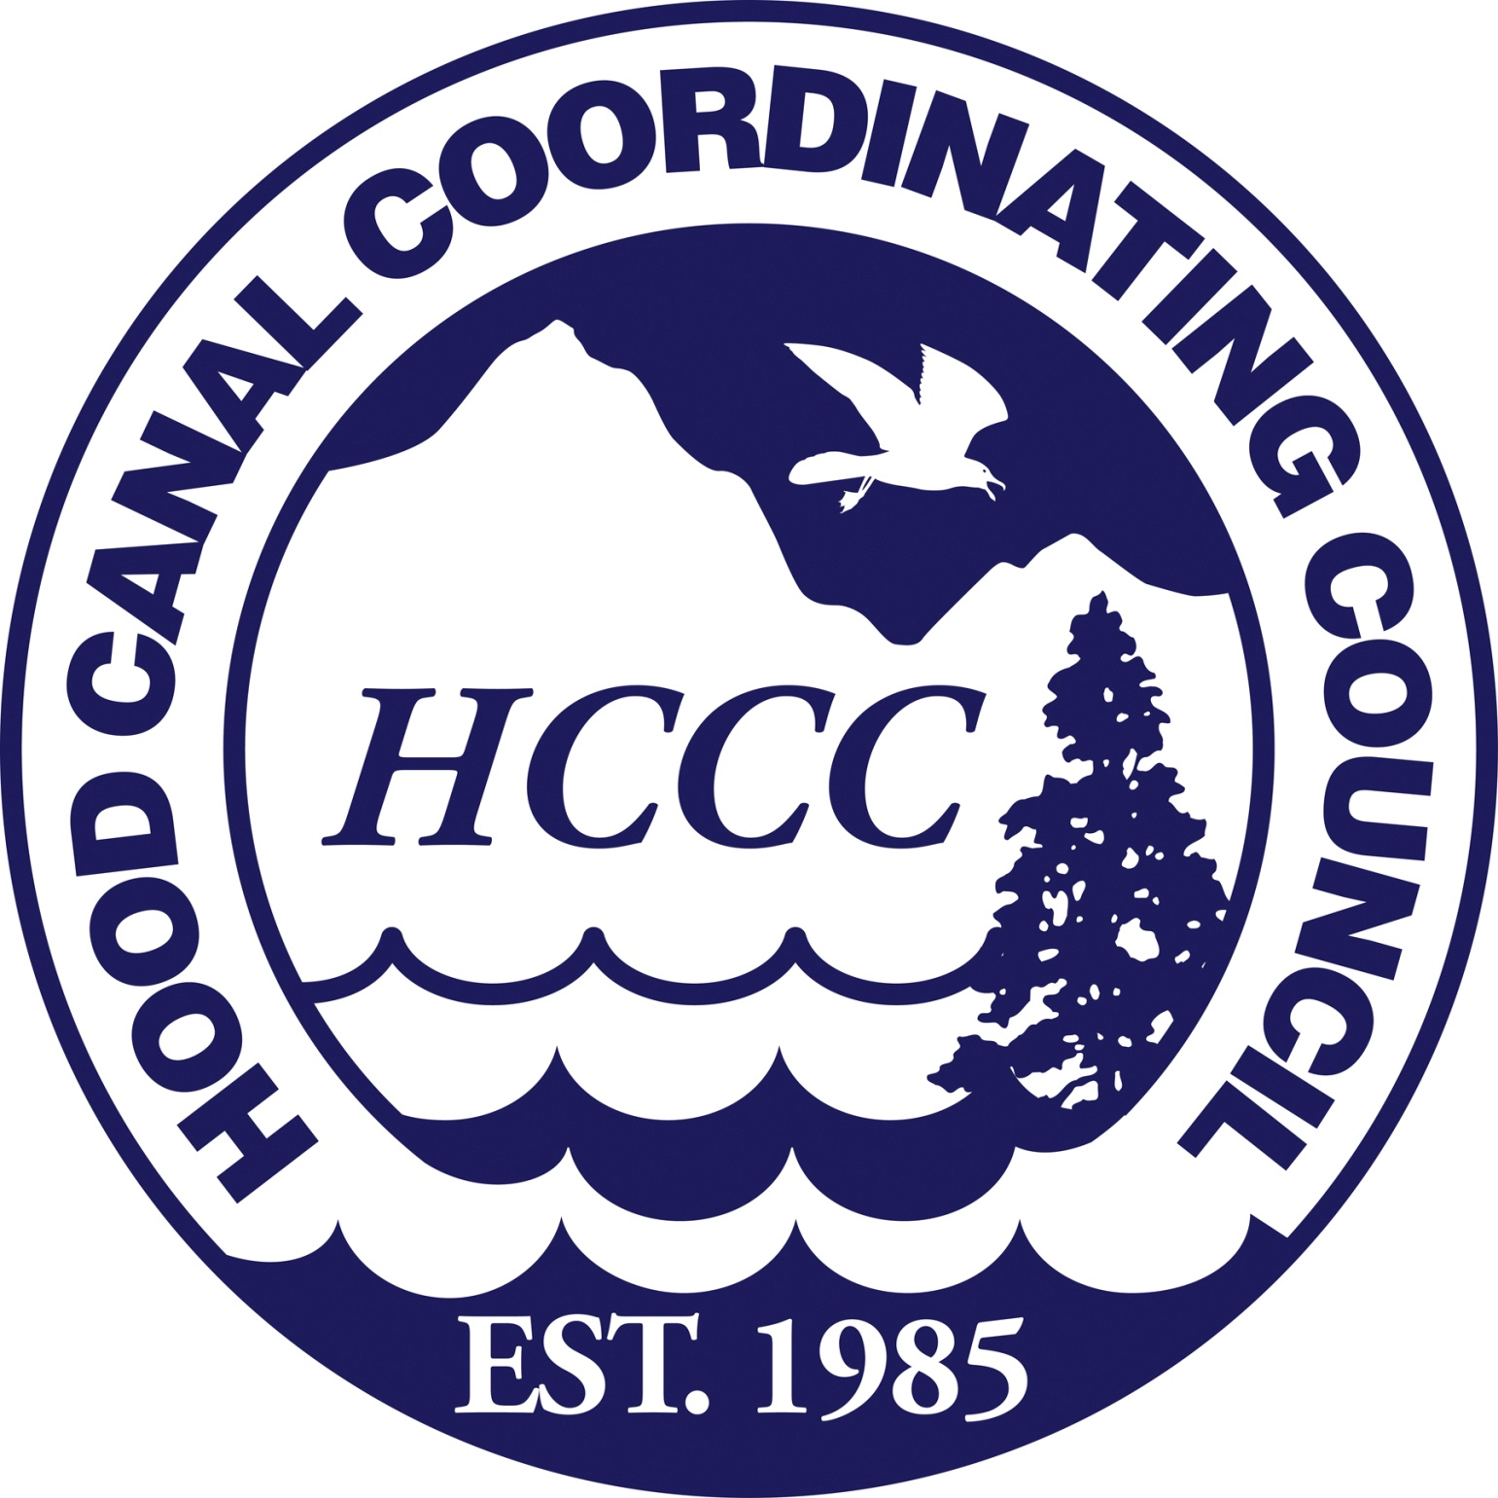

Board of Directors Annual Meeting and Retreat – Draft Agenda
14 June 2016; 12:00 PM to 4:00 PM
Location: Oxford Suite, 9550 NW Silverdale Way, Silverdale, WA

12:00 PM Call to Order, Introductions, Approval of Meeting Agenda
Randy Neatherlin, HCCC Chair

12:05 PM Public Comment (please limit time to approximately 2 min. per person)
Randy Neatherlin, HCCC Chair

12:10 PM Light lunch/refreshments

12:15 PM Consent Items
All matters listed under Consent Items have been distributed to each member of the Board for reading and study, are considered to be routine, and will be enacted by one motion of the Board with no separate discussion. If a separate discussion is desired, that item may be removed from the Consent Items and placed as an additional topic by request.

- Draft Board Meeting Summary 10 May 2016
- Cash Disbursements
- Expenditures

HCCC Board Outcome: Motion to approve consent items.

12:20 PM HCCC Program Budget Approval (7-1-2016 to 6-30-2017)
Scott Brewer, HCCC Executive Director
Tom Goishi, HCCC Accountant

- Review program goals, objectives and budget

HCCC Board Outcome: Motion to approve HCCC Program Budget.

12:40 PM HCCC Annual Review
Scott Brewer, HCCC Executive Director

HCCC Board Outcome: Board updated on HCCC program accomplishments and past year review.

1:00 - 4:00 PM Board of Directors Retreat

Economic Viability of Working Lands in Hood Canal:
Focus Discussion on Forestry/Shellfish/Navy

1:00 PM Invited panel representing the following focus economic sectors:
- Forestry – Adrian Miller, Olympic Resource Management
- Shellfish – Lissa Monberg & Tiffany Waters, Hama Hama Co.,
Bill Dewey, Taylor Shellfish Farms
- Navy – Captain Thomas Zwolfer, Commanding Officer, Naval Base Kitsap
- Economic Trends – Trina Wellman, Northern Economics Inc.
2:30 PM Break
2:45 PM Invited Panel and Board Q&A Discussion
- Vision/Mission – Build and strengthen relationships
- What role do industries have in human wellbeing/environmental stewardship?
3:45 PM Panel Discussion Wrap-up

HCCC Board Outcome: The Board has received information and input from various economic sectors in the Hood Canal.

4:00 PM Adjournment and Next Meeting
Randy Neatherlin, HCCC Chair

Next meeting: Tuesday 12 July 2016, 1:00 PM to 4:00 PM, Oxford Suites, 9550 NW Silverdale Way, Silverdale, WA.
For more information about this meeting, contact Robin Lawlis, 360-394-0046 or rlawlis@hccc.wa.gov.
HCCC Board of Directors

Charlotte Garrido, Kitsap County
David Herrera, Skokomish Tribe
David Sullivan, Jefferson County
Edward Wolfe, Kitsap County
Jeromy Sullivan, Port Gamble S’Klallam Tribe
Kathleen Kler, Jefferson County
Paul McCollum, Port Gamble S’Klallam Tribe
Phil Johnson, Jefferson County
Randy Neatherlin, Mason County
Rob Gelder, Kitsap County
Terri Jeffreys, Mason County
Tim Sheldon, Mason County

Exofficio Members
Partnership Ecosystem Coordination Board for Hood Canal
Puget Sound Partnership
US Navy Region Northwest
Washington State Dept. of Ecology
HCCC Staff

Alicia Olivas, Lead Entity Program Coordinator
Haley Harguth, Watershed Planning and Policy Coordinator
Heidi Huber, Programs Development Coordinator
Patty Michak, Mitigation Program Manager
Robin Lawlis, Administrative Program Manager
Scott Brewer, Executive Director
Tom Goishi, Accountant

The Hood Canal Coordinating Council is a Watershed-Based Council of Governments consisting of Jefferson, Kitsap and Mason Counties and the Port Gamble S’Klallam and Skokomish Tribes. It was established in 1985 in response to community concerns about water quality problems and related natural resource issues in the watershed.

Mission: The Hood Canal Coordinating Council, working with partners, community groups and citizens, will advocate for and implement regionally and locally appropriate actions to protect and enhance Hood Canal’s environmental and economic health.

Visit www.ourhoodcanal.org for more information on the Integrated Watershed Plan.

Board meetings schedule and documents can be found on the website at www.hccc.wa.gov

